**Big Data Management - Assignment 5**

**Redis Data Management**

**Akshay Kumar (G24AI1033)**

**Github Link -**

**1. Install the redis-py library**

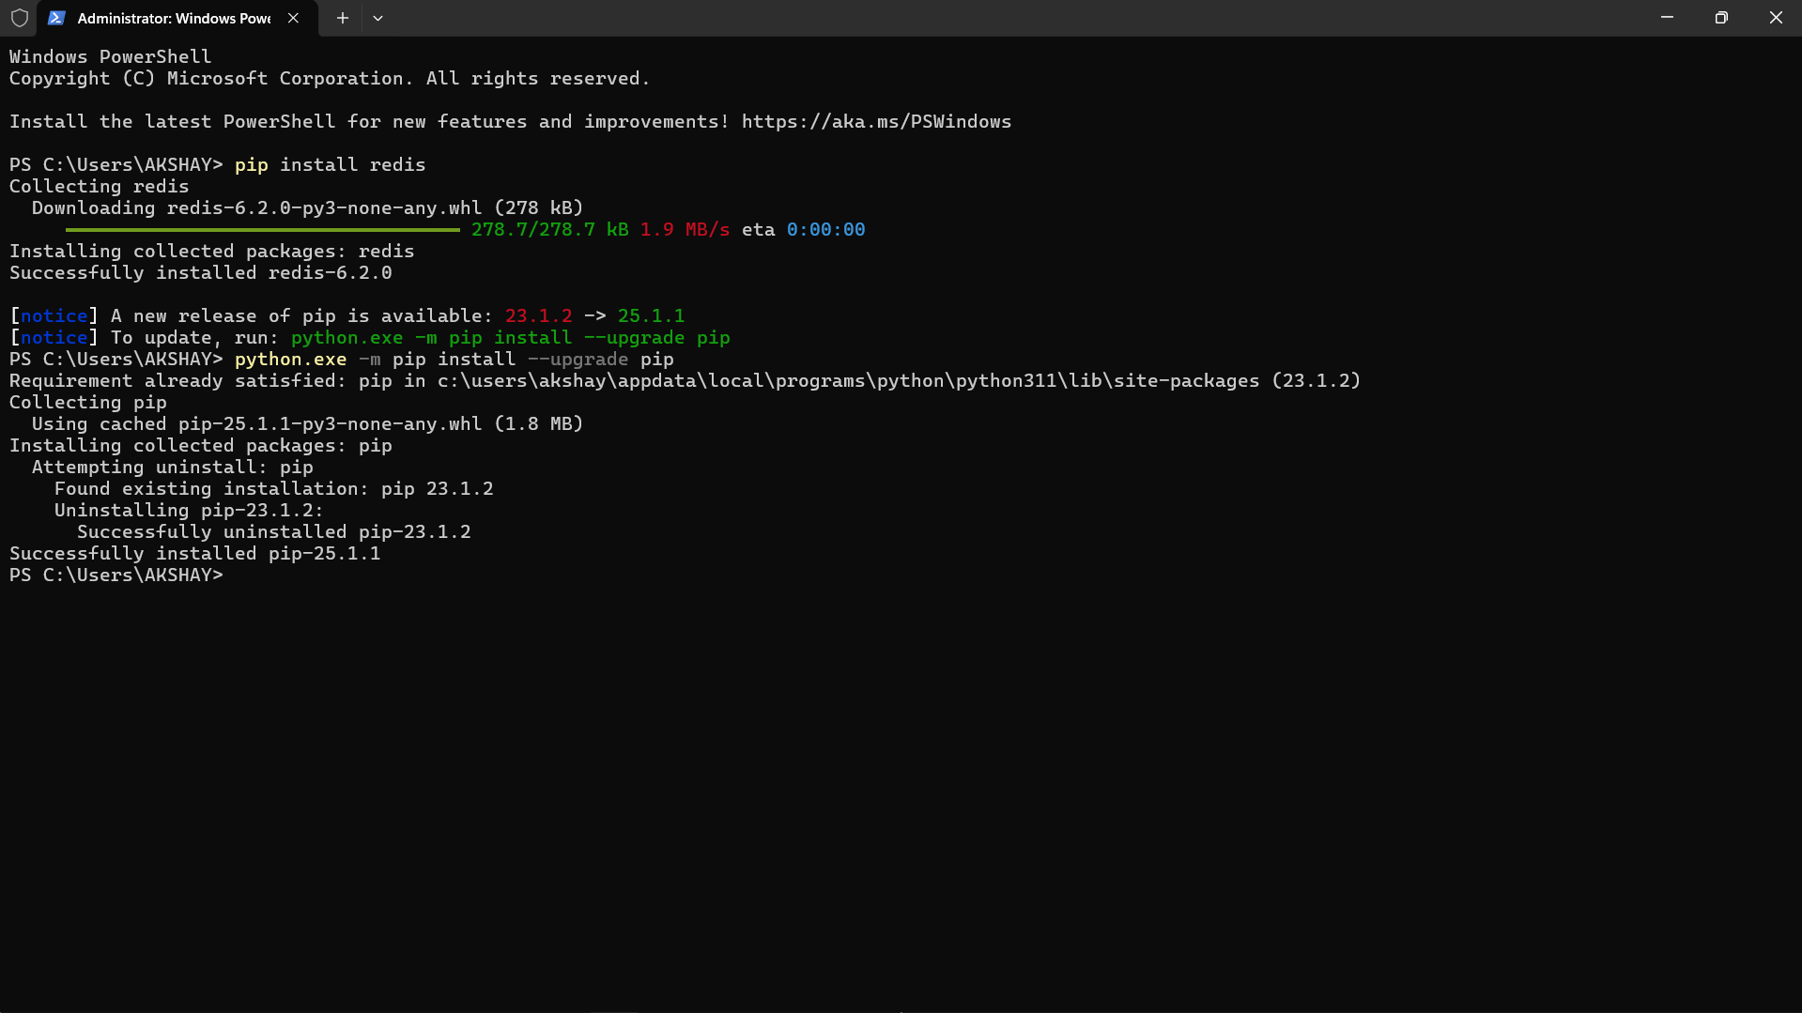

**2. Get your Redis Database Connection Details (Using Docker)**

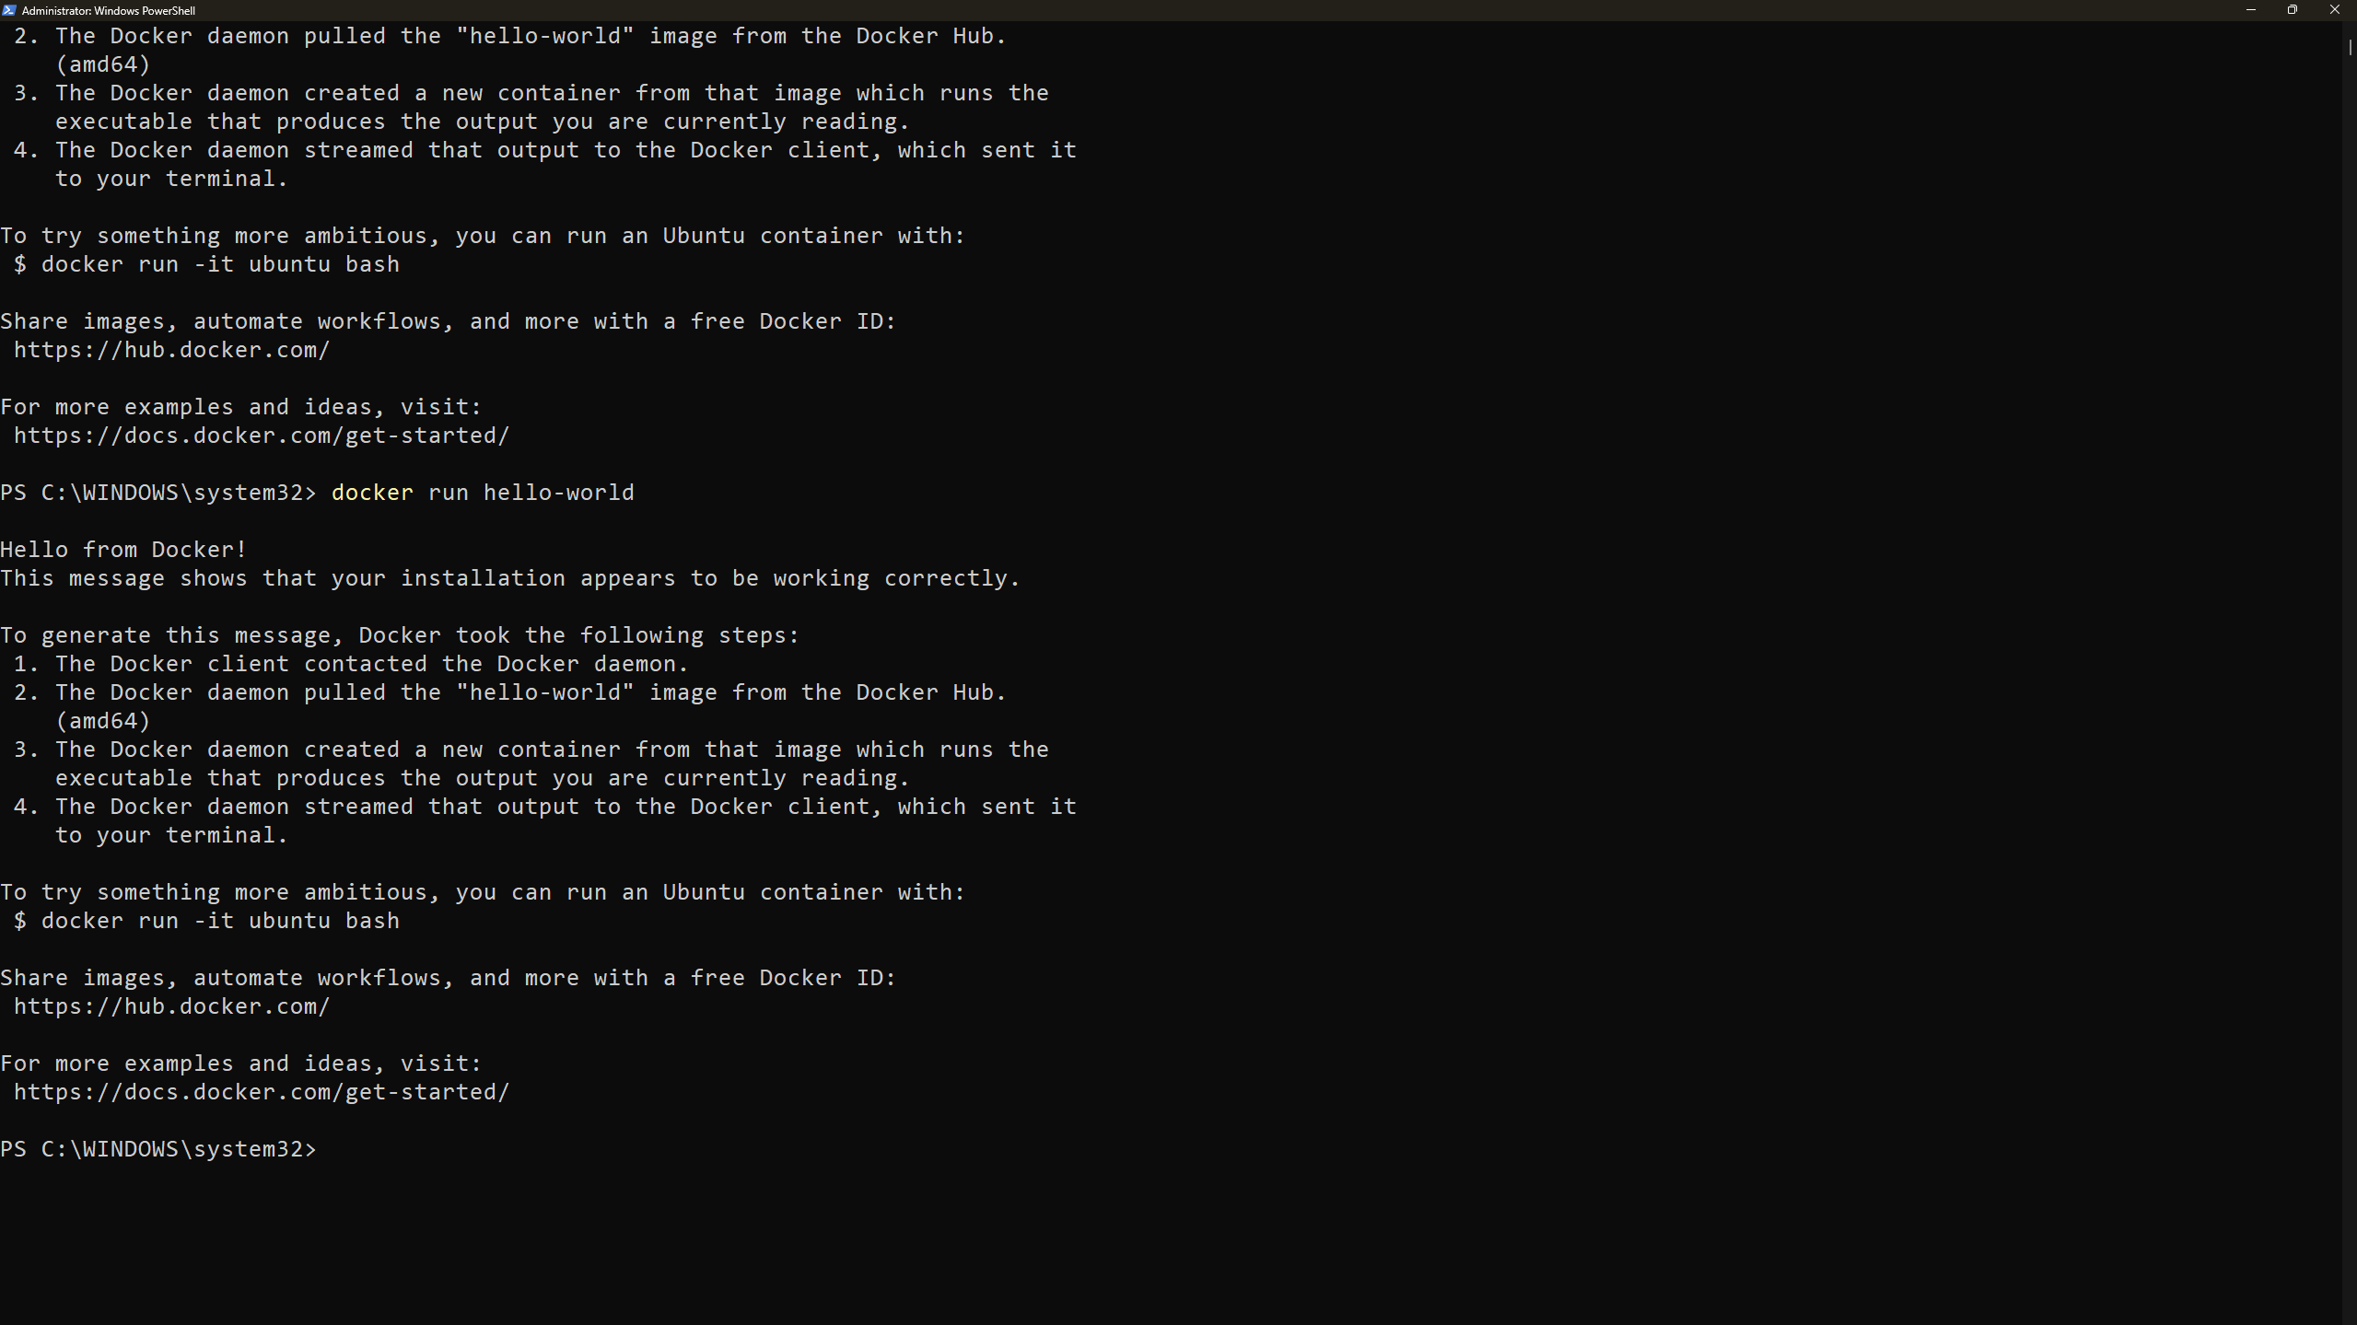

3. Running the Redis Docker Container

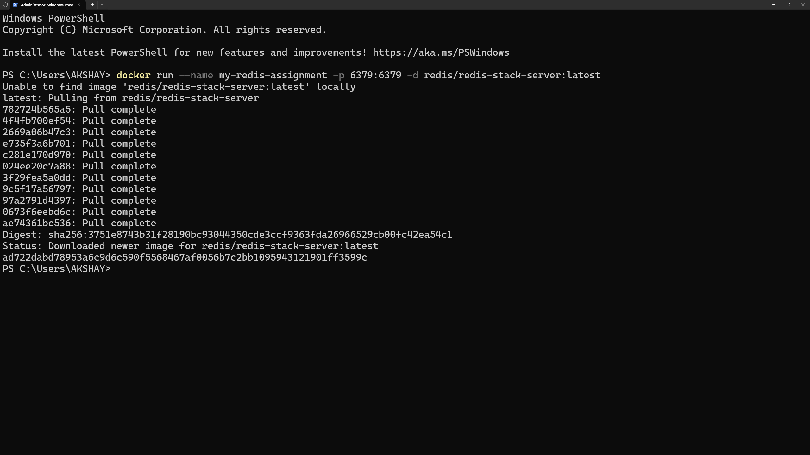

**4. Adding the basic structure and connect() method**

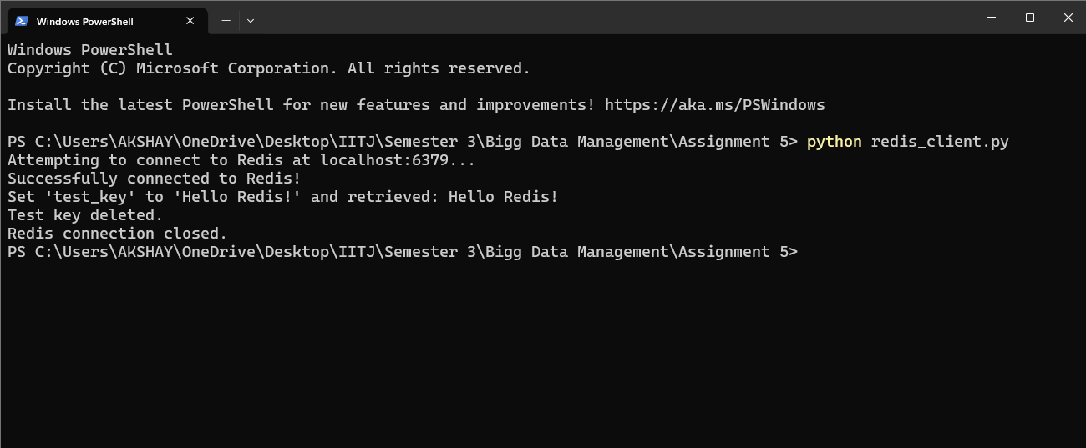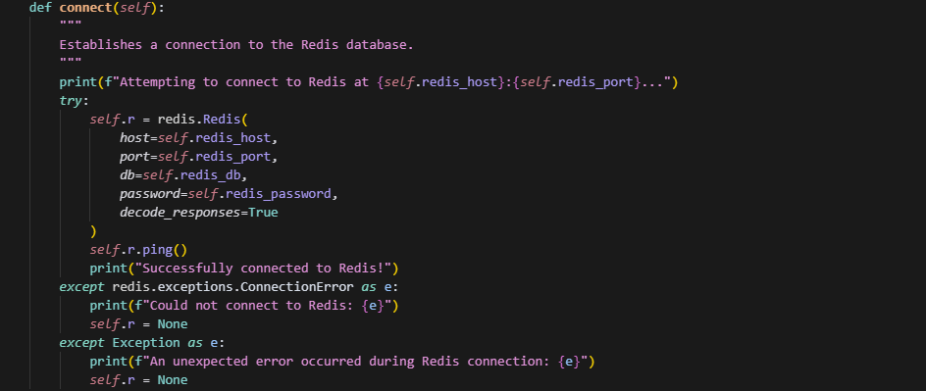

5. Implement load_users(self, file_path)

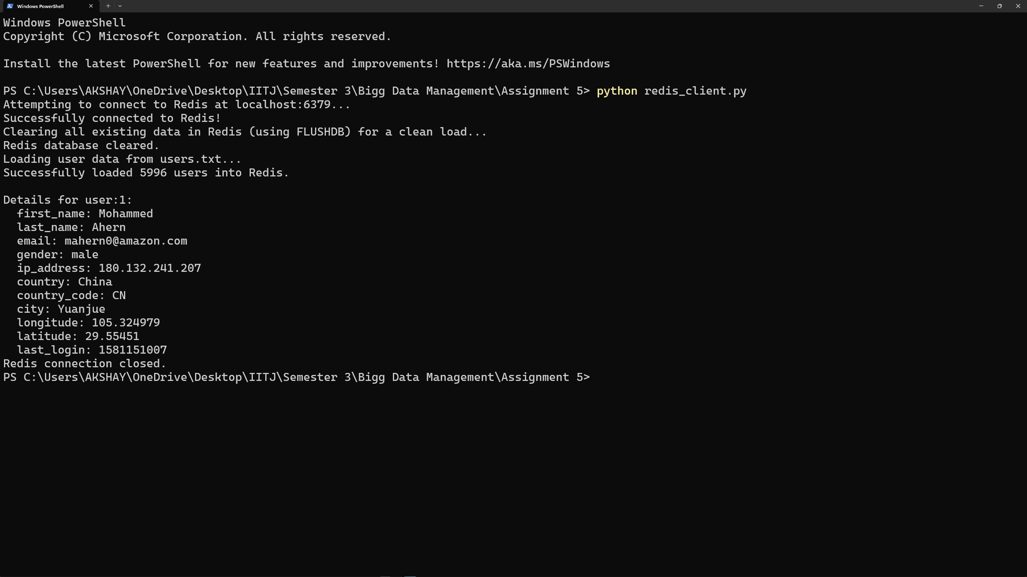

**6. Query1() :** This method retrieves all stored attributes for a specific user, identified by their user ID.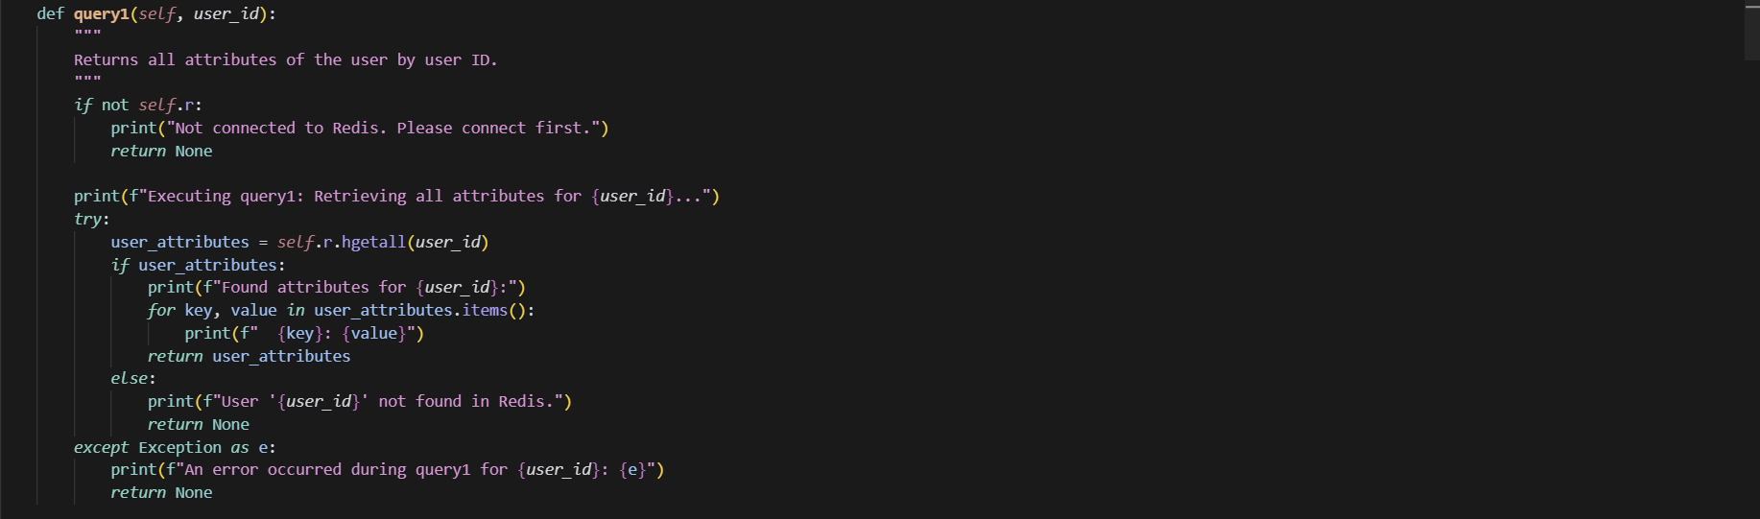

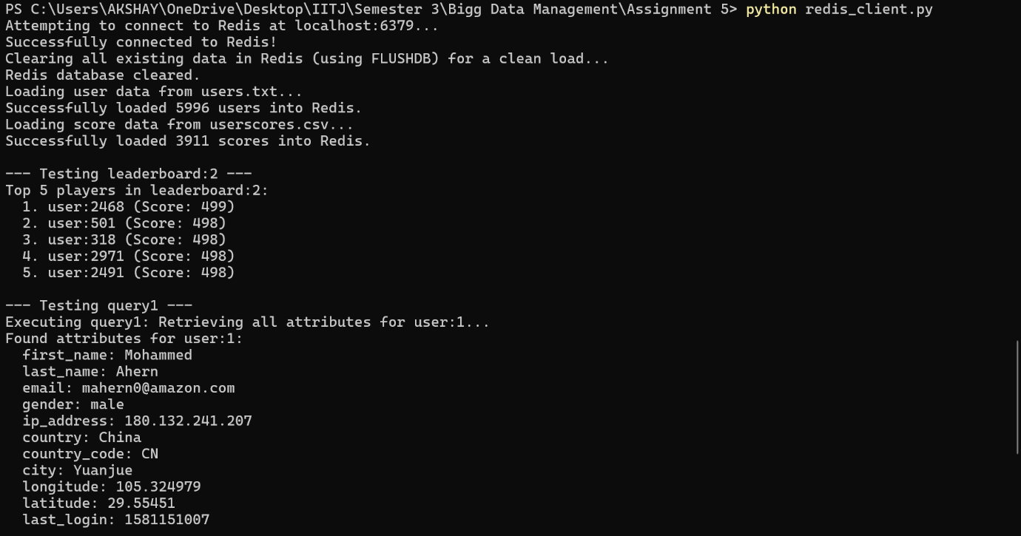

**7. Query2() :** This method fetches the longitude and latitude coordinates for a specific user ID.

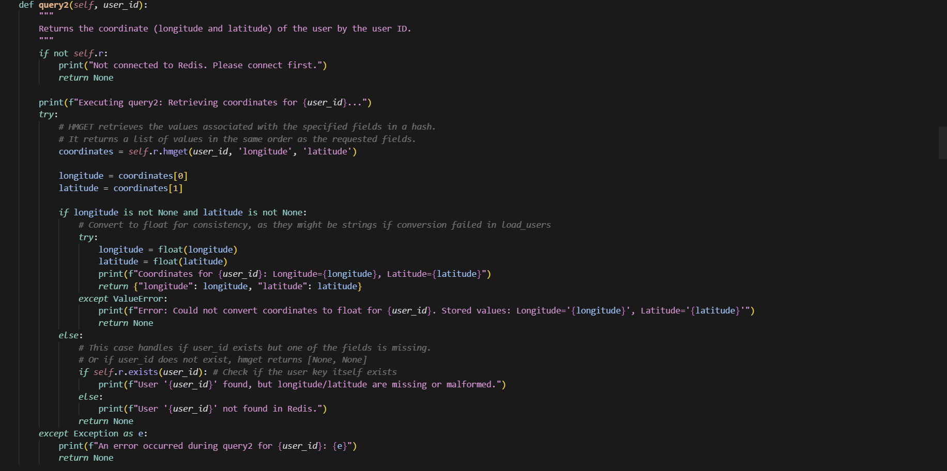

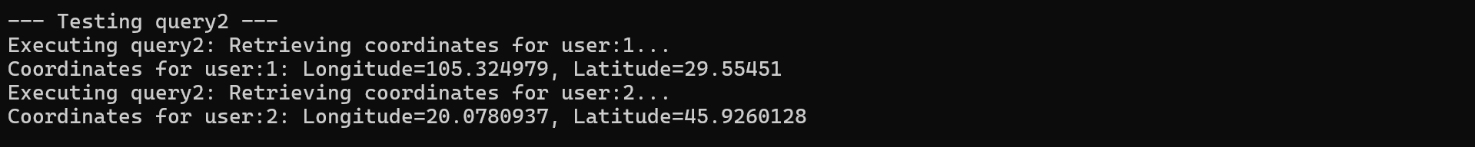

**8. Query3() :** This method scans the user keyspace, filters for users whose IDs do not start with an odd number, and returns their keys and last names.

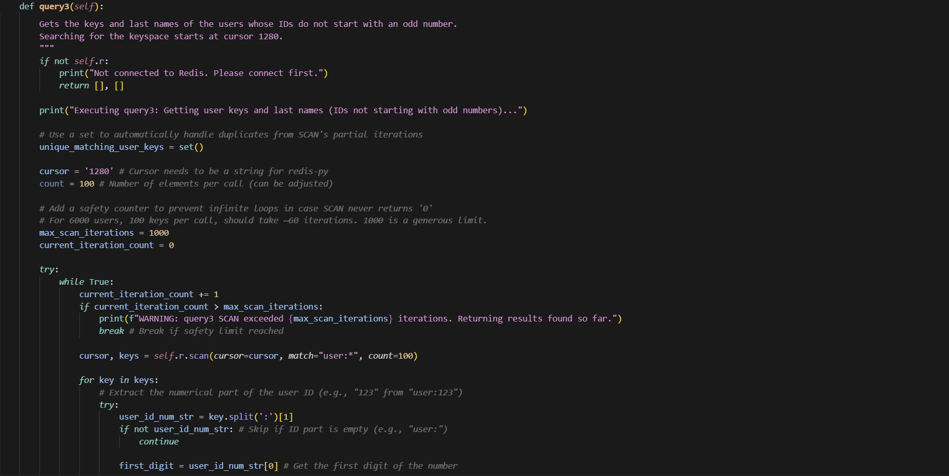

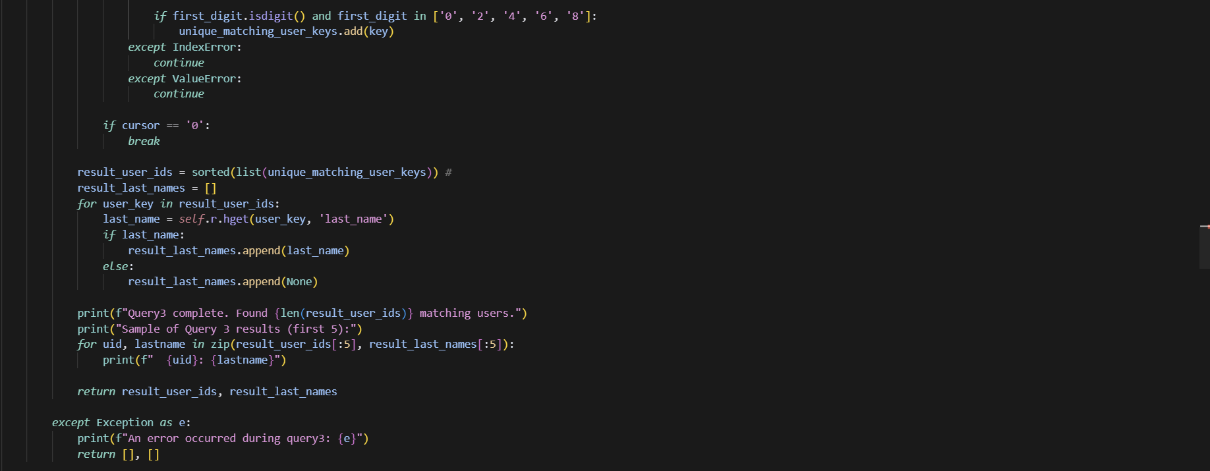

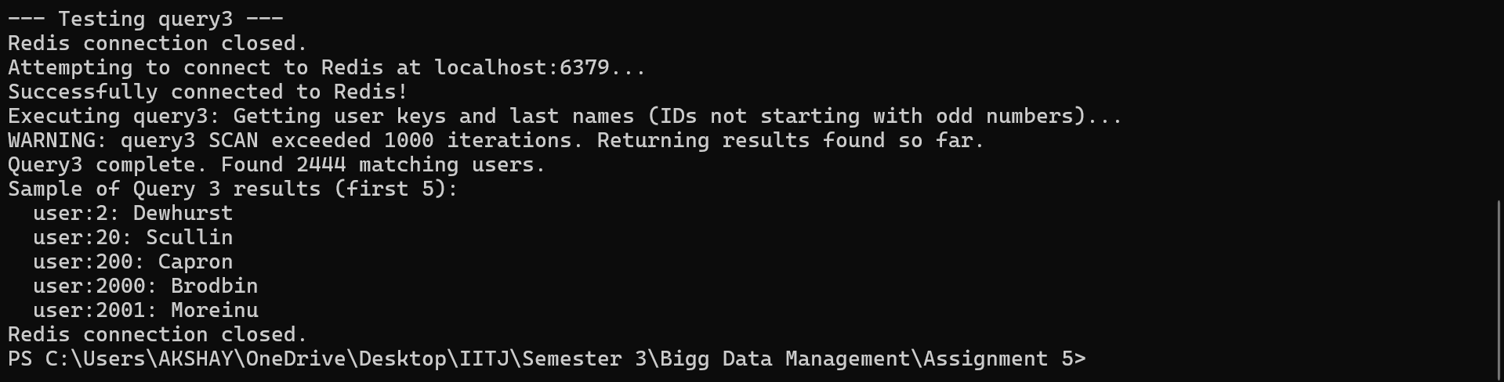

**9. Query4() :** This method creates a secondary index in Redisearch to enable efficient querying on specific user attributes like gender, country, latitude, and first name.

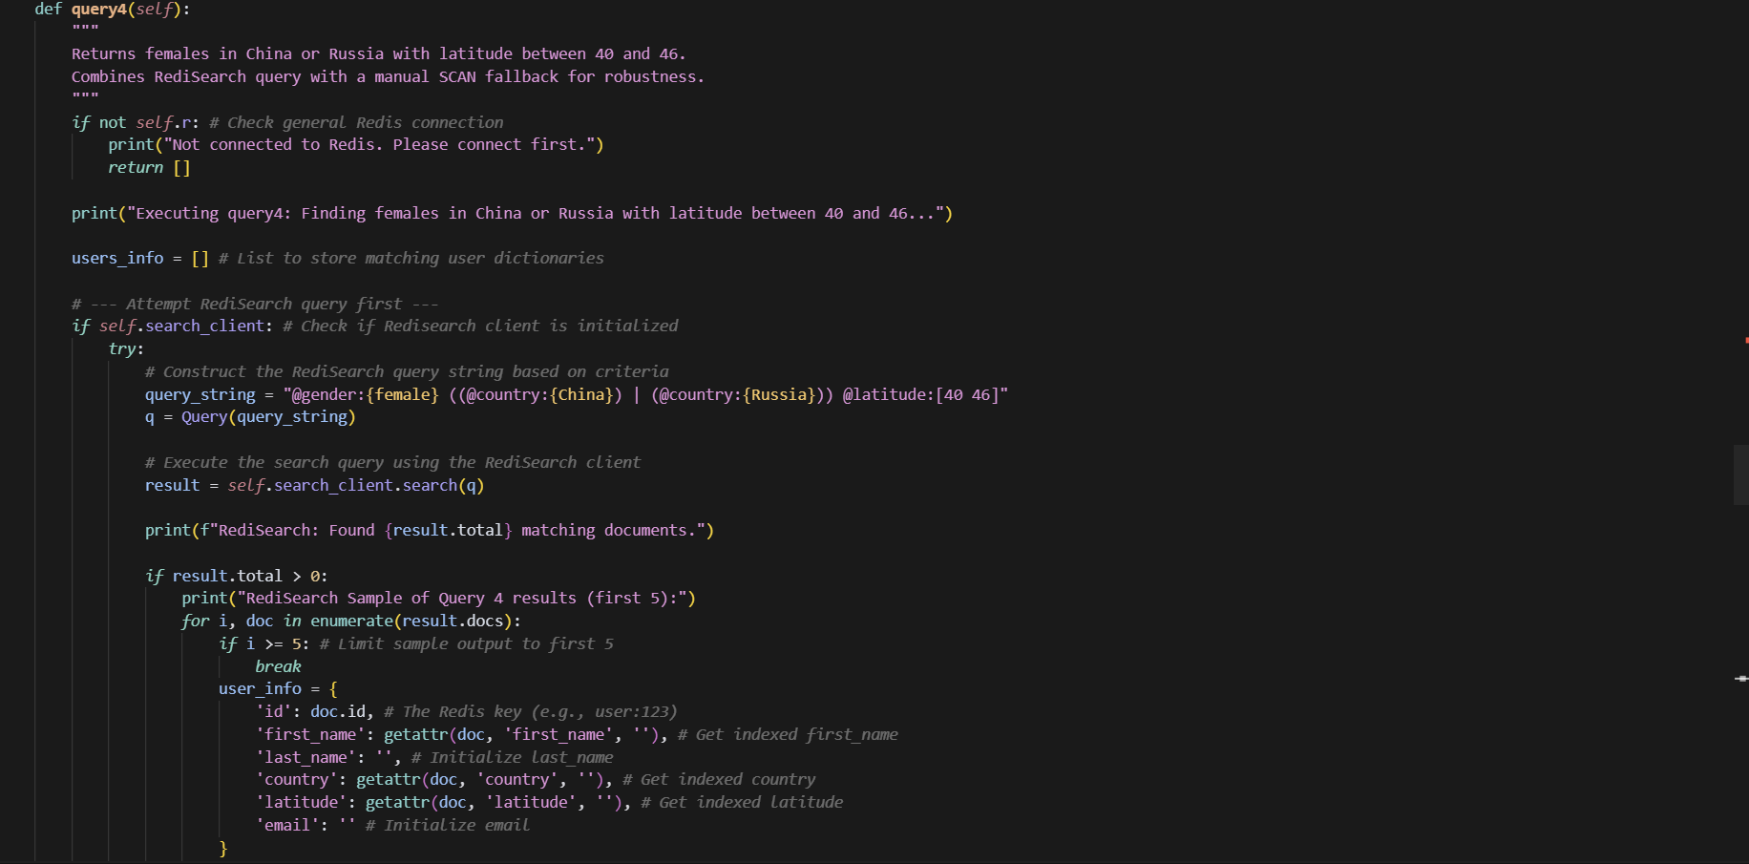

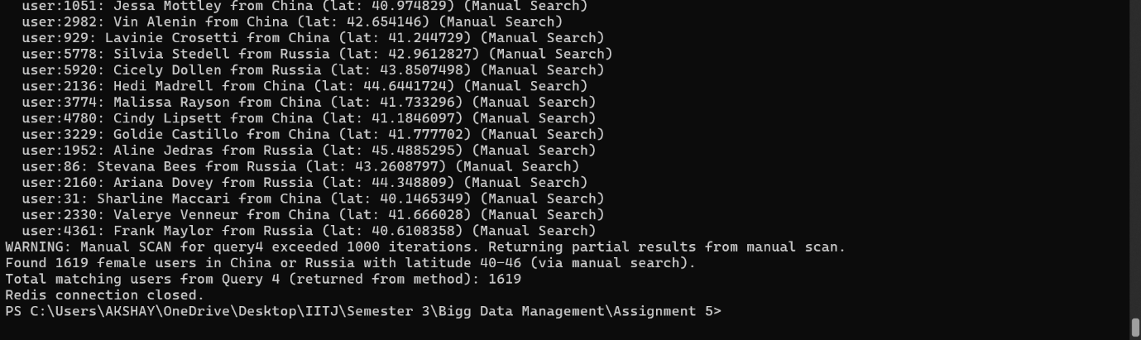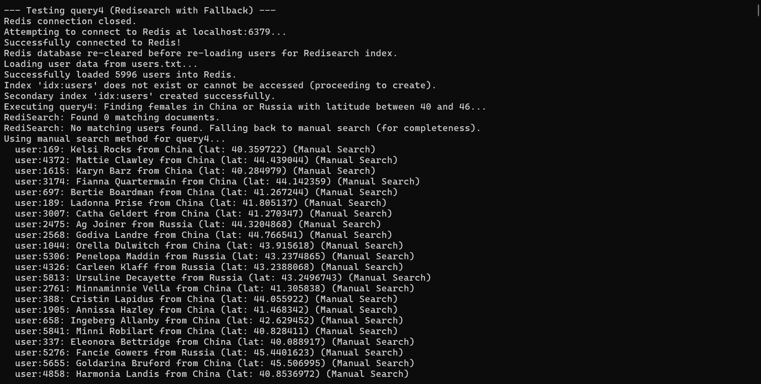

**10. Query5() :** This method finds female users in China or Russia with a specific latitude range (40 to 46), first attempting a RediSearch query and falling back to a manual scan if RediSearch fails or yields no results.

